**Authors:** Jaden Jefferson

**Last Updated:** 24 Mar 2025

# Connecting to Internet through Wall Port

## Objective:

* Convert to an L3 switch
* Set default-gateway and ip route to that of the universities wall port
* Set VLAN 2 to allow DHCP

## CLI Set Up

switch1>enable

switch1#config t

switch1#ip routing

switch1#ip route 0.0.0.0 0.0.0.0 10.12.112.1

switch1(config)# interface vlan 2

switch1(config-if)# ip address dhcp

switch1(config-if)# no shutdown

switch1(config-if)# end

switch1#write memory

## Physical Set Up

Plug an ethernet cable of cat5 or 6 into any port 7 through 12. If unsure of the ports contained in vlan 2. Run *show vlan brief* if unsure.

Plug the other end into the wall port that contains the default-gateway

## Confirming

switch1# show running-config | include default-gateway

switch1# show ip route

switch1# show ip interface brief

switch1# show interfaces vlan 2

## Testing

switch1# ping 10.12.112.1

switch1# ping 8.8.8.8

**Test 1:** Pinging 8.8.8.8 - Internet

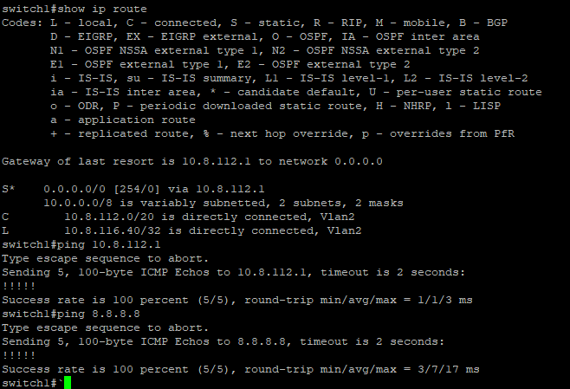

**Test 2:** Pinging 10.8.112.1 - Default Gateway

